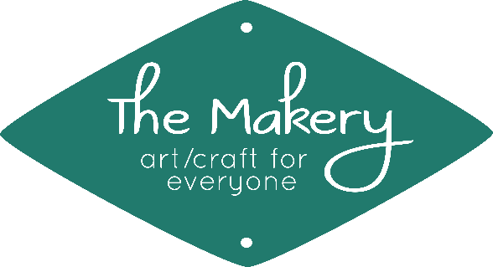
2019 Creative Workshop Calendar

Workshops for Adults (ages 15 to 115!)
July
Backstrap Weaving with a Rigid Heddle 7/6, 1 to 4 pm; $25/$5 materials fee
Needle-Tatted Earrings 7/7, 1 to 4 pm; $20/$5 materials fee
Bookbinding: Long Stitch 7/27, 10 am to 1 pm; $25/$10 materials fee
Intro to Kumihimo 7/30, 1 to 4 pm; $25/$7 materials fee
August
Bookbinding: Pamphlet Stitch 8/3, 1 to 4 pm; $25/$10 materials fee
Beginning Crochet 8/4, 8/11, & 8/18, 2 to 4 pm; $55 (provide own materials)
Circle Weaving 8/17, 1 to 4 pm; $25/$8 materials fee
September
Intro to Freestyle Weaving 9/8, 9/15, & 9/22, 2 to 4 pm; $55/$15 materials fee
Crochet Granny Squares 9/20, 1 to 4 pm; $25 (provide own materials)
Bookbinding: Buttonhole Stitch with a Soft Cover 9/21, 1 to 4 pm; $25/$10 materials fee
October
Suminagashi 10/12, 1 to 4 pm; $25/$5 materials fee
Handprinted Fabric: Stamps and Stencils 10/13, 1 to 2:30 pm; $10/$10 materials fee
Bookbinding: Secret Belgian 10/26, 10 am to 1 pm; $25/$10 materials fee
Funky Hat Class (Floor Loom Weaving) 10/27, 1 to 4 pm; $35/$5 materials fee
November
Hot Glue “Batik” 11/2, 1 to 4 pm; $25/$10 materials fee
Drop Spindle Spinning 11/3 & 11/10, 2 to 4 pm; $35/$5 materials fee
Handprinted Fabric: Block Printing 11/16, 1 to 4 pm; $25/$15 materials fee
Bookbinding: Cross Stitch 11/17, 1 to 4 pm; $25/$10 materials fee
December
Bookbinding: Mini Tied Binding with a Case 12/7, 1 to 4 pm; $25/$7 materials fee
Glass-Etched Votive Holders 12/8, 2 to 3:30 pm; $10/$5 materials fee
Handprinted Fabric: Simple Screenprinting 12/21, 2 to 4 pm; $15/$15 materials fee

Unless otherwise noted, all necessary materials and equipment will be provided for your use during the workshop.
For more information (and to find even more creative opportunities!),
please visit The Makery’s website at www.makerysvc.com.
Space in our workshops is limited to 6 people (or fewer, depending on the workshop)!
Register early to reserve your spot (and help us better prepare).
If we do not have enough people signed up 24 hours in advance, we may need to cancel a workshop.
Register online anytime at www.makerysvc.com, call us at 575-590-1263,
or stop by The Makery at 106 East Market in historic downtown Silver City (open limited hours—see website for details).

