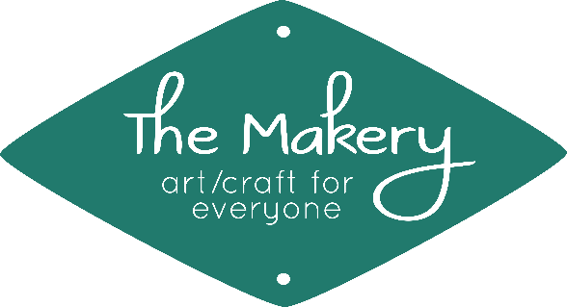
Fall 2018 Creative Workshop Calendar

Workshops for Adults (ages 15 to 115!)
September
*Wet-Felted Potholder 9/8, 10 am to Noon; $15/$3 materials fee
*Paper Beads x 2 9/15 & 9/22, 10 am to Noon; $30/$3 materials fee
*Inkle Weaving 101 9/16, 2 to 4 pm; $25/$5 materials fee (includes one-week loom rental after workshop)
*Bookbinding: Lightning Stitch Notebook 9/22, 1 to 2:30 pm; $15/$3 materials fee
October
*Bookbinding: Drop-in Stab Binding 10/7, anytime between 10 am-1 pm part of the Southwest Print Fiesta “drop-in pass”
*Wild Weaving on a Little Loom 10/8, 9 am to Noon; $25/$6 materials fee
Tablet Weaving 10/13, 1 to 4 pm (to 5 pm, optional); $25/$5 materials fee
*Reverse Dyeing, Three Ways 10/14, 1 to 3:30 pm; $20/$10 materials fee
*Bookbinding: French Link Stitch 10/28, 1 to 4 pm; $25/$10 materials fee
November
Beginning Crochet 11/8, 11/15, & 11/29, 6 to 8 pm; $55 (bring your own size K hook & “bulky”/size 5 yarn)
*Bookbinding: Japanese Stab Binding with Hinged Hard Cover 11/10, 1 to 4:30 pm; $30/$13 materials fee
*Shaving Cream Marbled Cards 11/17, 10 am to Noon; $15/$3 materials fee
Spinning: “Ply on the Fly” on a Turkish-style Spindle 11/18, 2 to 4 pm; $15/$3 materials fee
December
*Weave a Tool Roll-up Case 12/1, 1 to 5 pm; $35/$10 materials fee
Freeform Crochet 12/13, 12/20, & 12/27, 6 to 8 pm; $55/$3 materials fee
*Bookbinding: Two-needle Coptic Stitch 12/15, 1 to 3:30 pm; $20/$8 materials fee
Drop Spindle Spinning 12/22 & 12/29, 10 am to Noon; $35/$5 materials fee
Origami “Intention” Book 12/30, 1 to 3 pm; $15/$5 materials fee

*The products of these workshops would make wonderful holiday gifts!

Unless otherwise noted, all necessary materials and equipment will be provided for your use during the workshop.

For more information (and to find even more creative opportunities!),
please visit The Makery’s website at www.makerysvc.com.

Space in our workshops is limited! Register early to reserve your spot (and help us better prepare).
If we do not have enough people signed up 24 hours in advance, we may need to cancel a workshop.

Register online anytime at www.makerysvc.com, call us at 575-590-1263,
or stop by The Makery at 206 North Bullard in historic downtown Silver City.

